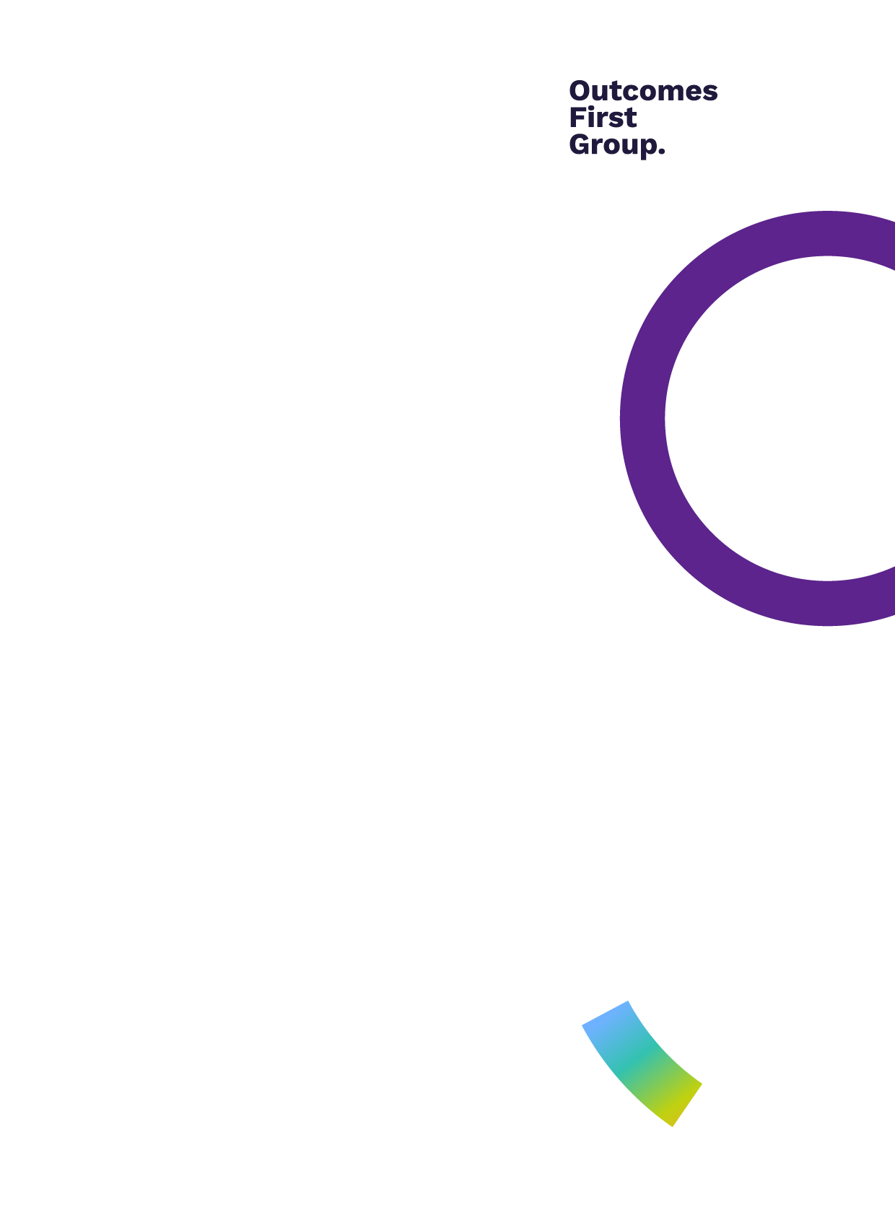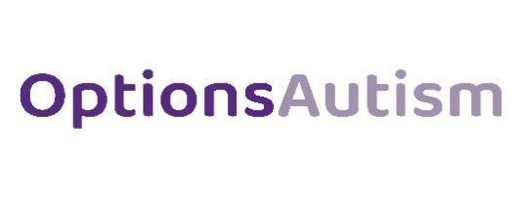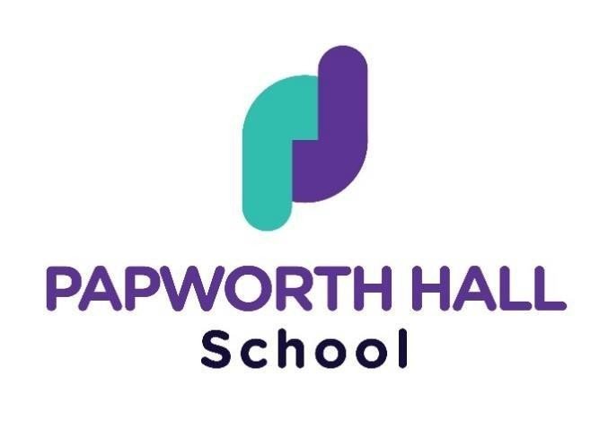

School

Informal & Semi-formal

Curriculum & Assessment Policy

Papworth Hall School

**Policy Owner: Headteacher Karen Page Date of Publication: September 2023**

**Policy: Curriculum Policy Next Review Date: August 2026**

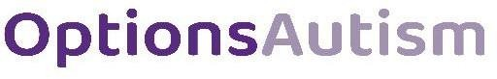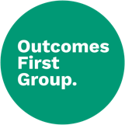

|  |  |
| --- | --- |
| Policy Review Process | |
| Created by | Headteacher |
| Date of implementation | June 2023 |
| Date of most recent review | August 2025 |
| Next policy review | August 2026 |

**Curriculum & Assessment Policy**

**Contents**

**1.0 Introduction** 2.

**2.0 Intent 3**

**3.0 Implementation 4**

* 1. **Impact 8**

# Introduction

### Whole School Mission Statement

At Papworth House School we are committed to enhancing the lives of all our young people so they can all become ‘**C**urious,

**C**ourageous, **C**ommunicators, and **C**onfident learners’, in our community this is known as “the Four C’s”.

We aim to…

1. Support our children and young people to grow and develop in the following ways;
   * Safe – be safe, feel safe, and understand risk
   * Understanding – be effective and successful communicators
   * Kind – be kind to all around them, to understand and respect the needs of others
   * Happy – be healthy and happy individuals who enjoy coming to school
   * Ambitious – have goals and dreams for their futures and be supported to achieve them
   * Successful – find regular achievement and celebrate this as part of a community
2. Facilitate individual progress and attainment for all our pupils, through effective understanding of their needs as a learner, with autism and complex needs and the effective implementation of appropriate curriculum, teaching strategies and assessment tools to ensure pupils acquire the academic, vocational, and life skills necessary to continue their learning when they leave Papworth Hall School.
3. Increase pupil’s ability to function in a communal educational setting: developing their everyday functioning and skills in the areas of social communication, play and imagination, and in their ability to learn and acquire new skills and understanding.
4. To prepare each pupil for a meaningful and purposeful transition to life as an adult regardless of developmental stage.
5. To ensure accurate reporting to parents, carers, Local Authorities, Government agencies, and additional significant others as required.

# Intent

### Curriculum Mission Statement

At PHS we want our pupils to be immersed in a curriculum that supports them to experience and develop an understanding of;

* skills to support functional communication, interaction, and reading skills, enabling effective communication and safe access to a variety of community settings and wider learning opportunities.
* skills to support emotional regulation, linked to physical and sensory needs, ensuring safe access to a variety of community settings and wider learning opportunities.
* skills to support social, emotional, and mental health, developing independent living and life skills that will support safe access to a variety of community settings and wider learning opportunities.
* what it means to be a human and how human behaviour impacts and shapes the world they live in.
* the visual, cultural, social and environmental aspects of the wider world and where they live.
* the natural world and an appreciation for the animal species that inhabit the world and live alongside them.
* how to compare through the investigation and exploration of various processes and materials.
* the significance of people, places, events and inventions that have helped to change the world in which they live.

At PHS we recognise that all pupils will need to develop core communication and interaction skills, learn how to manage their physical and sensory needs, impacting positively on their social, emotional, and mental health before they are able to immerse themselves in the wider demands of the curriculum.

* + 1. **Implementation**

### “The Golden Thread” – Education, Health and Care Plans (EHCPs)

Every pupil that attends the school has an Education Health and Care Plan (EHCP) which outlines the pupils personalised needs, provision to support overcome barriers to learning and sets out long term outcomes within four/five areas of SEND:

* + Communication & Interaction
  + Sensory & Physical
  + Cognition & Learning
  + Social, Emotional & Mental Health
  + Independence (Preparing for Adulthood - PfA) - Statutory from Year 9, however all pupils have an independence/preparing for adulthood target.

We recognise that all pupils will need to develop core communication and interaction skills which will support them to manage their physical and sensory needs which will in turn will impact positively on their social, emotional and mental health. With those three key areas of need addressed at that point pupils can begin to immerse themselves in the wider demands of the curriculum and work towards the development of key skills, knowledge, and understanding driving forward towards future progress and attainment.



**Communication**

**& Interaction**

**(Communication Profile)**

**Cognition**

**& Learning**

**(Personalised**

**Education Plan)**

**Social, Emotional**

**& Mental Health**

**(High quality pastoral support)**

**Physcial &**

**Sensory**

**(Sensory Profile)**

The understanding of personalised SEND, the implementation of prescribed provision and targeted EHCP outcomes combine to form the golden thread of each pupil’s individual curriculum provision, lesson planning and assessment, and impact on every aspect of each pupil’s education.

Every pupil has Long Term EHCP Outcomes that broken down into short term learning intentions. Long-Term and Medium-Term Planning is then developed to support progression against these intentions and evidence is gathered via our in-school assessment methods.

At PHS we want all our pedagogical approaches to focus on the pupil, their skills, interests and needs. We want all of our staff to understand how each pupil's Autism affects them and use research-based strategies to overcome any barriers to learning. We want all of our pupils to be educated in an environment that "speaks to them" through the use of visual structure, environmental organisation and the structuring of teaching and learning experiences that promote independence. This organisation and structure should be broad-based and should support the pupils not only in the classroom but during social/leisure times and in the community. We want our teaching to be flexible and responsive to the changing needs of our pupils so they can be engaged, calm and happy learners.

### “All about me” – Personalised Education Planning

**Each pupil at PHS will have their own individual education plan** **(we do not do this)–** we refer to them as our “All About Me” files. This ensures every pupil has access to a curriculum, pedagogy and provision that is tailored to their specific needs, interests, and talents.

Upon entry to the school the team work with each pupil, as well as their parents or carers, to develop a communication profile and sensory profile which will become part of their daily school life, enabling the pupil and staff to help them to build on their strengths and increase their resilience around any identified areas of need.

The clinical therapy team operate predominately using an integrated therapeutic model. This largely consists of different therapeutic disciplines working together to provide training, consultation, and modelling of strategies for staff within the classroom. This ensures that clinical provision is integrated into the whole school environment, and that pupils learn to implement and generalise the use of skills regularly, with the guidance of their support staff.

Personalised planning as already identified starts with the pupil’s EHCP. A review of strengths and weaknesses regarding special education need to inform key documents like Risk Assessment, Positive Behaviour Support Plans.

The pupil’s EHCP, Risk Assessment, Positive Behaviour Support Plan, then influence the provision map that is created to ensure they all necessary provision to meet their special educational needs is in place, ensuring all access to learning is safe, and with as many barriers to learning removed as possible.

Long-Term Outcomes are broken down into smaller Short-Term IEP targets with aim of reviewing progress against these desired outcomes termly 3 times per year.

### Curriculum Pathways

At PHS we have three identified curriculum implementation pathways to support a pupil centred delivery of our curriculum intent. Pupils can move between pathways and have a mix of curriculum experiences and assessment opportunities dependent on their developmental stage.

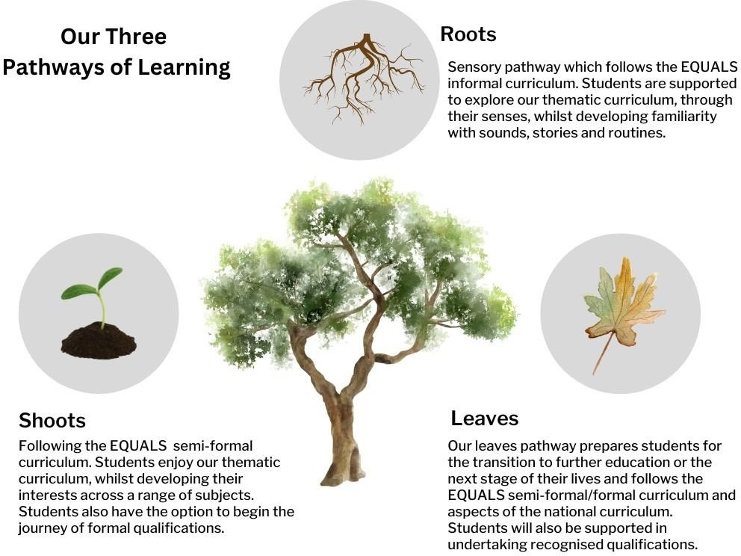

|  |  |
| --- | --- |
| **Curriculum Intent** | |
| * skills to support functional communication, interaction, and reading skills, enabling effective communication and safe access to a variety of community settings and wider learning opportunities. * skills to support emotional regulation, linked to physical and sensory needs, ensuring safe access to a variety of community settings and wider learning opportunities. * skills to support social, emotional, and mental health, developing independent living and life skills that will support safe access to a variety of community settings and wider learning opportunities. * what it means to be a human and how human behaviour impacts and shapes the world they live in. * the visual, cultural, social and environmental aspects of the wider world and where they live. * the natural world and an appreciation for the animal species that inhabit the world and live alongside them. * how to compare through the investigation and exploration of various processes and materials. * the significance of people, places, events and inventions that have helped to change the world in which they live. | |
| **Curriculum Implementation Equals Informal Pathway - Roots** | **Curriculum Implementation**  **Equals Semi-formal Pathway – Shoots & Leaves** |
| My Sensory Play My Communication  My Thinking  My Physical Well-being My Independence My Outdoor School  Careers and Employability Skills Fundamental British Values / SMSC / Celebration  PSHE | Literacy (including Accelerated Reader & Rocket Phonics)  White Rose Maths (Numeracy) ICT  The World About Me My Communication  My Independence |
|  | My Outdoor School My Play and Leisure  My Relationships and Sex Education Careers and Employability Skills  Fundamental British Values / SMSC / Celebration |

Equals Informal Curriculum Pathway – Roots : Our ‘Roots’ learners are establishing the foundations of learning, language and independence skills. 'Roots’ learners are developing awareness and autonomy regarding social thinking, problem solving, self- regulation, independent living and community awareness and presence. They will also be working on developing their repertoire of social and leisure-based interests as well as honing important self-directed learning and organisational skills.

|  |  |
| --- | --- |
| **Equals Informal Pathway** | |
| **Curriculum Area** | **Focus** |
| My Sensory Play | Solitary play Parallel play Shared play Turn taking play  Co-operative play |
| My Communication | Imperative communications Declarative communications  Formal social interaction with familiar People Peer to peer communications  Alternative and augmentative communications |
| My Physical Well-being | Sensory integration and sensory circuits Other play-based activities  Aquatics  Mental Health and Well-being Relationships and sex education |
| My Independence | My dressing and undressing My travel training  My shopping My cooking |
| My Outdoor School | Starting out Orienteering Shelter building Using and open fire  Cooking outdoors |
| My Love of Reading | Personalised experiences of reading Focus texts |

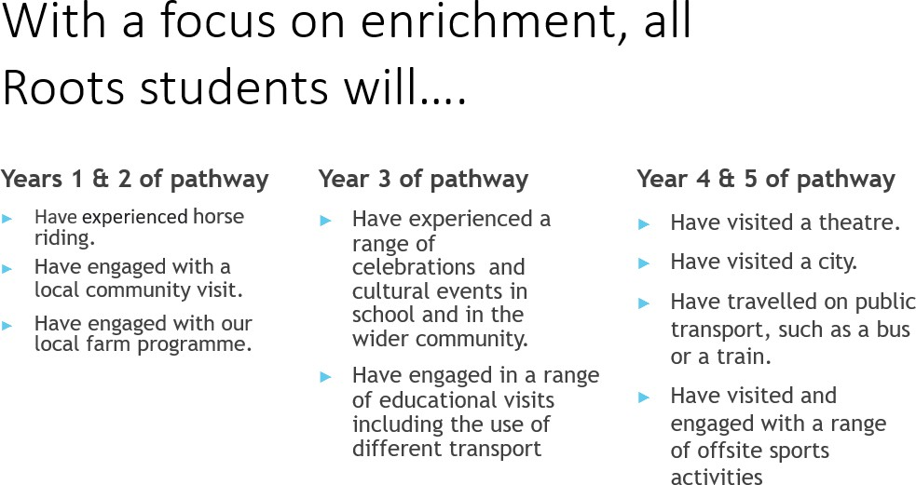

Equals Semi-Formal Curriculum Pathway – shoots & leaves: The semi-formal curriculum recognises that many of our pupils have a range of complexobstacles to learning as well as learning difficulties. We meet each pupil’s needs through a personalised approach, delivered through a bespoke curriculum offer appropriate for pupils identified as having a severe learning difficulty, but who are developing skills thatmeans they are ready to study some aspects of subject specific learning. Like the Informal Curriculum offer, pupils will experience learning opportunities that centre around communication, cognition, social and emotional development and sensory processing support (when pupils reach Year 9 and beyond, their agreed outcomes will also reflect the areas of Employment, Community Inclusion, Independent Living and Health as part of a Preparing for Adulthood [PfA] focus). Some pupils, if applicable, will be expected to work towards accreditation in awards and certificates that make use of formal accreditation schemes that are carefully matched to their needs

|  |  |
| --- | --- |
| **Equals Semi-formal Pathway** | |
| **Curriculum Area** | **Curriculum Focus** |
| Literacy (inc. Accelerated Reader & Rocket Phonics) | Literacy for sharing information Literacy for the future  Literacy for life and leisure Literacy for information |
| Numeracy | Maths in everyday Life Maths for the future Maths for the community Maths for life  Maths for design |
| The World About Me | Water The weather The seasons  Recycling People  Life cycle of plants and animals Food  Festivals Digital photography  Change, history and the passing of time |
| My Communication | Imperative communications Following instructions Declarative communications Dynamic communications Narratives  Formal social interactions with familiar and unfamiliar people Personalised reading and writing  Non-verbal, behaviour communications Peer to peer communications  Augmentative and alternative communications |
| My Independence | My travel training My shopping  My dressing and undressing My cooking food / technology |
| My Outdoor School | Starting out Playing games Creativity  Wilderness explorers Environmental Awareness Seasonal Awareness Shelter building  Making a fire Cooking outdoors |
| My Play and Leisure | Structured Play Free Play |

|  |  |
| --- | --- |
| PSHE & My Relationships and Sex Education PSHE Association | Families and people who care for me Caring Friendships  Being Safe (including online) Healthy Eating  Knowing my body Knowing me Private and public  Touching and allowing others to touch me Forming relationships (including online relationships)  Sexual intimacy with another person |
| Careers and Employability Skills | Careers and labour market information Curriculum linked to careers  Encounters with employers and employees |
| Fundamental British Values / SMSC / Celebration | Democracy Rule of Law  Respect & Tolerance Individual Liberty  Self-knowledge, Self-esteem, Self-confidence Zones of Regulation (Managing my own behaviour)Cultures and Traditions |

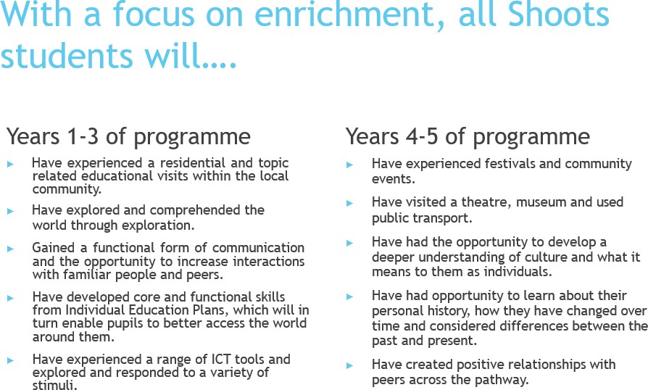

#### Determining a Curriculum Pathway for pupils:

Pupils are baselined upon entry to determine developmental stage linked to Pre-Key Stage Standards.

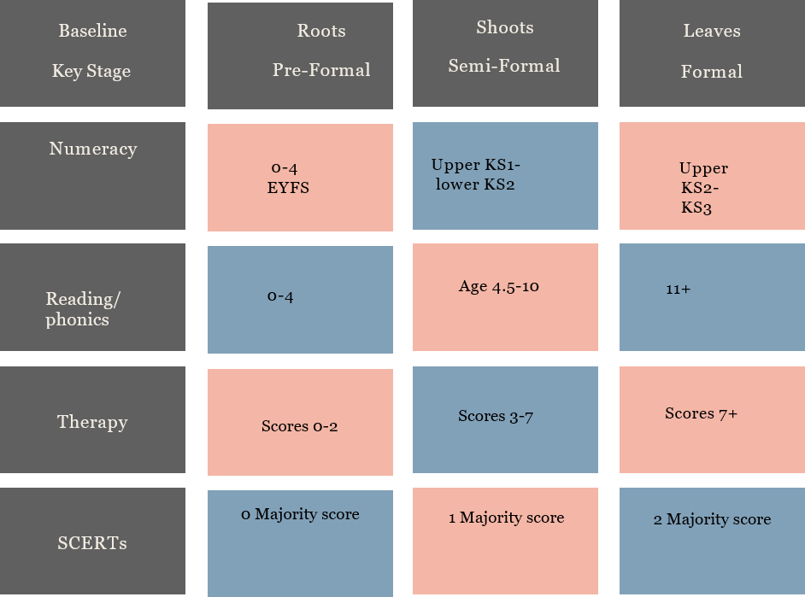

1. Focused Attention: The ability to respond discretely to a particular visual, auditory, or tactile stimuli. Sometimes called

“orienting” to stimuli. It is the lowest level of attention or alertness.

1. Sustained Attention: The ability to sustain a steady response during continuous attention.
2. Selective Attention: The ability to maintain attention in the face of distracting or competing stimuli.
3. Alternating Attention: The capacity for mental flexibility that allows the shift of focus between tasks. People with alternating attention deficits are slow to shift their attention from one task to another. This can also affect conversations. The person will have difficulty with switching conversational topics quickly.
4. Divided Attention: The ability to respond simultaneously to multiple tasks or to do more than one activity at a time. People with divided attention deficits might have difficulty driving and holding a conversation or cooking and listening to the news.

|  |  |  |
| --- | --- | --- |
| **Baseline Assessment Area** | **Informal** | **Semi-formal** |
| **Level of Attention** | Working towards “Focused Attention” | Working towards “Sustained Attention” |

## Impact

Demonstrating progress at Papworth Hall School: Cognition & Learning

Long Term Progress - Progress against Long Term Outcomes are reviewed as part of the annual review process. These outcomes reflect long term aspirations normally across a key stage and are used to measure progress over time. These outcomes can link to accreditation pathways such ASDAN Personal Progress Award or Entry Level Qualification where appropriate.

Short Term Progress - Long Term Outcomes are broken down into short term outcomes and linked to either the Informal or Semi- Formal Curriculum Outcomes. We recognise that the needs of pupils mean that progress needs to be measured and recorded outside of typical linear means. We therefore measure progress against an identified outcome using the AET framework. These outcomes are reviewed continuously but are reported on termly via the schools reporting processes. These outcomes are recordedvia each pupils Individual Progress Record.

#### Personal Development & Behaviour and Attitudes

Attendance - Many of our pupils will have experienced difficulties with attendance in previous settings either because of school refusal or their complex behaviours preventing them from attending school settings. We use improved attendance as an impact measure to highlight improved social and emotional well-being linked to behaviour and attitudes and personal development.

Behaviour - All of our pupils have come to PHS having experienced difficulties with managing their behaviour responses in previous settings leading to incidents of challenging behaviour. We use a reduction in number of behaviour events as impact measure to highlight improved social and emotional well-being linked to behaviour and attitudes and personal development.

At PHS we also use the Leuven scale to record engagement within lessons, this provides us with the opportunity to learn from what is working well and implement such positive techniques and interests across the students’ other lessons.

#### Reporting on Progress

Daily journals - Parents, Carers, & Social Workers receive a brief daily communication detailing highlights from the day and an overview of behaviour and achievements.

End of Term Pupil Progress Reports - Parents, Carers, & Social Workers receive an end of term report that details progress made against short term outcomes. These are discussed with parents during parents evening/meeting and for pupils who are LAC these are reviewed as part of the EPEP process.

End of Term Behaviour & Wellbeing Overview - Parents, Carers, & Social Workers receive and end of term overview of behaviour, attendance, and visually represented experience of pupil’s time in school.

Annual Review - Parents, Carers, & Social Workers are invited to attend an annual review meeting in person or virtually. A collation of evidence of progress is shared and submitted to the local authority along with any recommendations for any amends to Education, Health and Care Plans.



**We are part of the Outcomes First Group Family,by working together we will build incredible futures by empowering vulnerable children, young people and adults in the UK to be happy and make their way in the world**